Integrated sub-regional planning informed by weighted spatial network models:
The case of Jeddah Sub-regional system
Kayvan Karimi
Space Syntax Laboratory, Bartlett School of Architecture, UCL
k.karimi@ucl.ac.uk

Ed Parham
Space Syntax Limited, UK
e.parham@spacesyntax.com

Abhimanyu Acharya
Space Syntax Limited, UK
a.acharya@spacesyntax.com
Pages: xxx-xxx

Abstract
Existing Space Syntax methodologies provide the tools to measure the impact of proposed spatial changes, but are strongly dependant on the quality and availability of the spatial data. This becomes particularly more complex when major land use changes or development projects are proposed in a large region and there is no or very little spatial layout data available for them. To counter this problem it is suggested that an ‘integrated urban model’ can be developed by using land use and demographic data to supplement the lack of spatial layout data and create a more realistic model for evaluating planning decisions. This paper explores the use of a ‘weighted space syntax’ model to contribute to the process of integrated urban planning for a large urban region in a major planning exercise in Jeddah, Saudi Arabia. The study aims at identifying the growth pattern and development potentials of the Jeddah Sub-regional system along with testing planning proposals for its growth over the next twenty years. The method for allocating the weighting to the segments of spatial networks by dividing the city into ‘superblocks’, identified by the foreground network and morphological similarities or spatial conditions such as existing municipal districts and major development boundaries. The weighting is then applied to the segments per unit length since longer segments have a higher probability of having a higher number of plots. The output is a spatial analysis impacted by the land use distribution, which adds the attraction or repulsion to movement generated by certain land uses to the spatial configuration and provides an accurate depiction of the functioning of the city. With this methodology we are able to estimate the impact of any number of projects of varying scales, at different time periods. This model has been integrated into the planning process through working with the lead planners in Jeddah at different stages of the project in both informative and evaluative modes. The result is an iterative, evidence-based approach and a collaborative framework for the planning and decision making, which could be adopted in future planning for Jeddah or elsewhere.

Keywords
Planning process, sub-regional plans, integrated urban models, weighted space syntax analysis, planning option testing, rapid urbanisation.

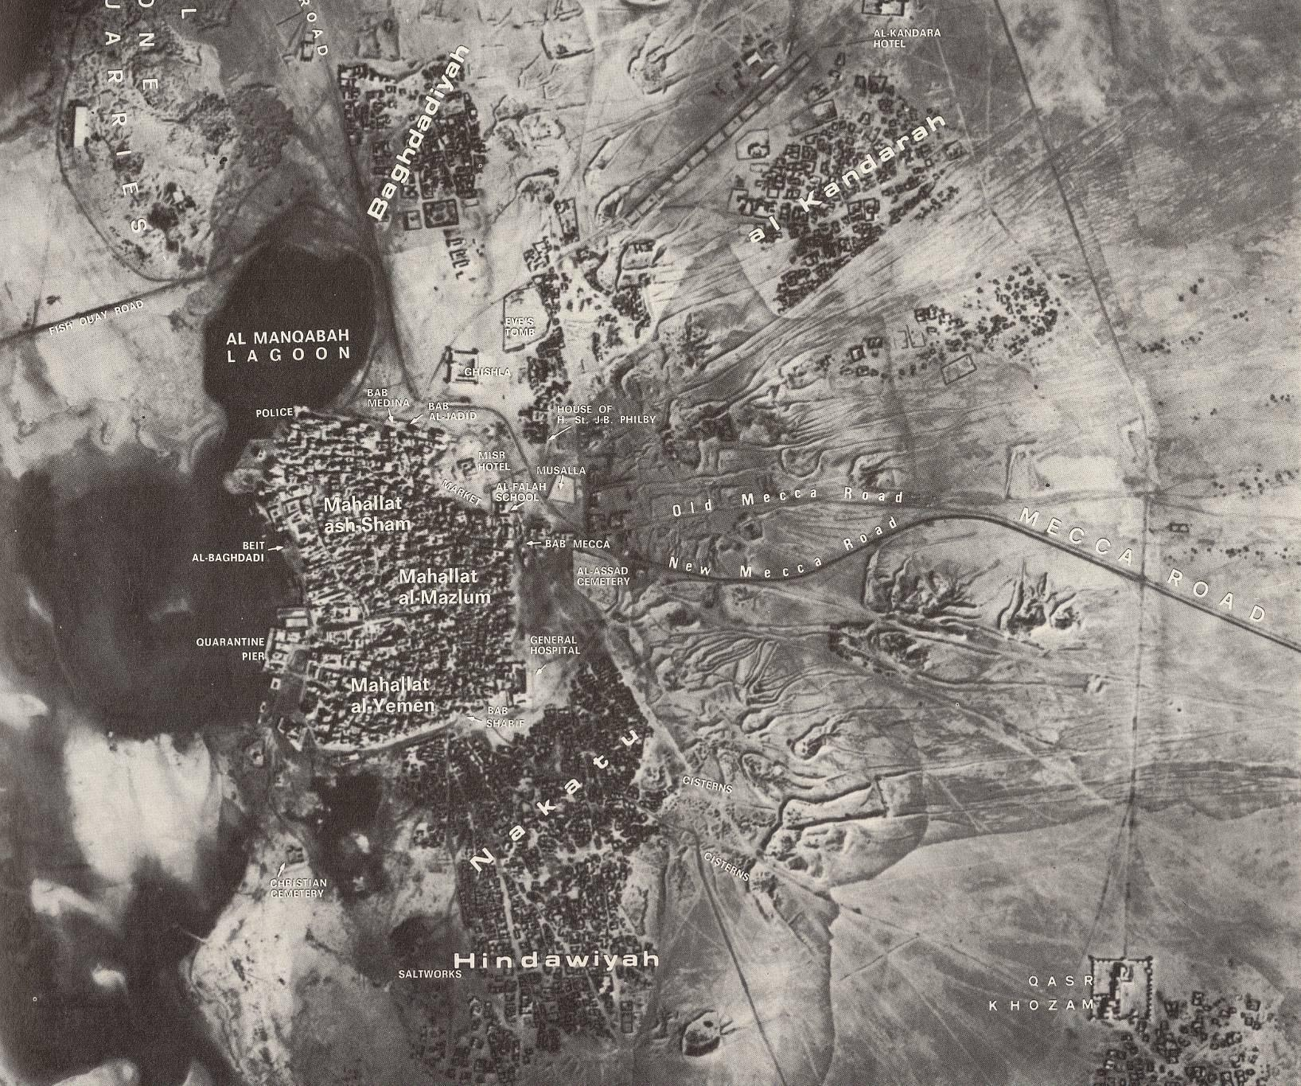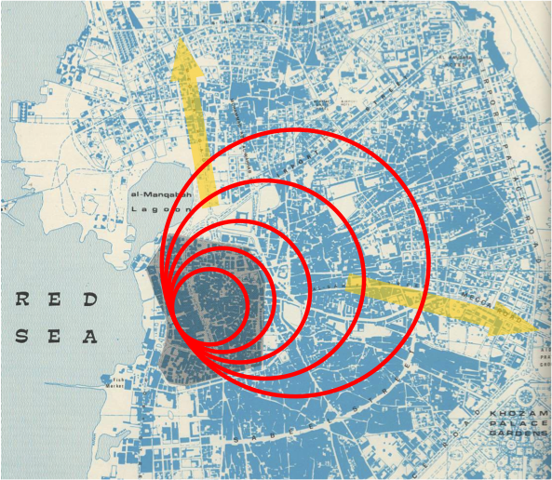
Figure 1: The City of Jeddah before modern transformations c.1947, left, and in the early stages of rapid growth, right (Space Syntax Limited, 2006)

References
AECOM. (2013). Jeddah Strategic Plan Revision. Jeddah, Saudi Arabia: Municiplaity of Jeddah.
AECOM. (2014). Jeddah Sub-Regional Plan, Sectoral reports. Jeddah, Saudi Arabia: Municiplaity of Jeddah.
Bahaydar, M. H. (2013). Urban Sprawl and Its Negative Effects on Jeddah.
Daghistani, A.-M. (1993, November). A case study in planning implementation, Jeddah, Saudi Arabia,. Newcastle.
Dhanani, A., Vaughan, L., Ellul, C., & Griffiths, S. (2012). From the axial line to the walked line: evaluating the utility of commercial and user‐generated street network datasets in space syntax analysis. In Eighth International Space Syntax Symposium. Santiago, Chile.
El-Shafie, M. (2010). Human-Environment Interactions: Phenomenal Relationships. International Journal of Civil & Environmental Engineering, 10(04), 21–29.
Griffiths, S., Vaughan, L., Haklay, M. (Muki), & Emma Jones, C. (2008). The Sustainable Suburban High Street: A Review of Themes and Approaches. Geography Compass, 2(4), 1155–1188. doi:10.1111/j.1749-8198.2008.00117.x
Hillier, B. (1996). Space is the Machine: A Configurational Theory of Architecture. Cambridge University Press.
Hillier, B. (2001). Centrality as a process: accounting for attraction inequalities in deformed grids. Urban Design International, 4(3), 107–127.
Hillier, B. (2002). A Theory of the City as Object: or, how spatial laws mediate the social construction of urban space. Urban Design International, 3-4(127), 153–179.
Hillier, B. (2009). Spatial sustainability in cities: organic patterns and sustainable forms. In Proceedings of the 7th International Space Syntax Symposium. Stockholm, Sweden.
Hillier, B., & Iida, S. (2005). Network and Psychological Effects in Urban Movement. In A. Cohn & D. Mark (Eds.), Spatial Information Theory (Vol. 3693, pp. 475–490). Springer Berlin / Heidelberg. Retrieved from http://www.springerlink.com/content/10853tquj1mpf95j/abstract/
Hillier, B., & Penn, A. (1996). Cities as Movement Economies. Urban Design International, 1(1), 49–60.
Hillier, B., Penn, A., Hanson, J., Grajewski, T., & Xu, J. (1993). Natural Movement: or configuration and attraction in urban pedestrian movement. Environment and Planning B: Planning and Design, 20, 29–66.
Hillier, B., & Stonor, T. (2010). Space Syntax - Strategic Urban Design. City Planning Review, The City Planning Institute of Japan, 59/no.3(285), 7–11.
Hillier, B., Yang, T., & Turner, A. (2012, January). Advancing DepthMap to advance our understanding of cities: comparing streets and cities and streets with cities [Proceedings paper]. Retrieved February 9, 2015, from http://www.sss8.cl/proceedings/
Karimi, K. (2009). New Towns of England in Transition: reshaping through understanding the reasons for failure. In Model Town: Using Urban Simulation in New Town Planning. Almere, Netherlands: International New Towns Institute.
Karimi, K. (2012). Evidence-informed and analytical methods in urban design. Urban Design International, 17(4), 253–256. doi:10.1057/udi.2012.24
Karimi, K., & Parham, E. (2012). An evidence informed approach to developing an adaptable regeneration programme for declining informal settlements. In Eighth International Space Syntax Symposium. Santiago, Chile.
Karimi, K., Parham, E., Fridrisch, E., & Ferguson, P. (2013). Origin-destination weighted choice model as a new tool for assessing the impact of new urban developments’. In Proceedings of the Ninth International Space Syntax Symposium.
Penn, A. (2008). Architectural Research. In A. Knight & L. Ruddock (Eds.), Advanced Research Methods in the Built Environment (pp. 14–27). Wiley-Blackwell.
Penn, A., Hillier, B., Banister, D., & Xu, J. (1998). Configurational modelling of urban movement networks. Environment and Planning B: Planning and Design, 25(1), 59–84.
Space Syntax Limited. (2006). Jeddah Strategic Planning Framework.

