999

Title
Subtitle
Author’s name; Affiliation; Contact details.

_________________________________________________________

ABSTRACT

Max. 250 words (Please delete before submission)
Here you write your abstract of your short paper. Write here what your research questions are, methods used and descriptions of the cases. At the end you write one to two sentences about the findings. Remember to fill inn the registration number of your paper at the left top corner (where you see the number 999)! Otherwise, your long paper might get lost in the system. Thanks a lot for your co-operation.

KEYWORDS

Max 5 Keywords (Please delete before submission)
Keyword 1, Keyword 2, Keyword 3, Keyword 4, Keyword 5

Introduction
Here you write the introduction of your contribution. This is the way you out references in the text from articles (Hillier 1999, Hillier et.al 2012) and from books (Hillier and Hanson 1984, p. 33).

theory
Here is another example of the next chapter. You can also call this chapter ‘litterature review’ or the methods of investigation.

Heading
Here is an example of a sub chapter. Below you see an image and how to place the title of the image. It shall be below the image. For tables, you have to put the caption for the table on the top.
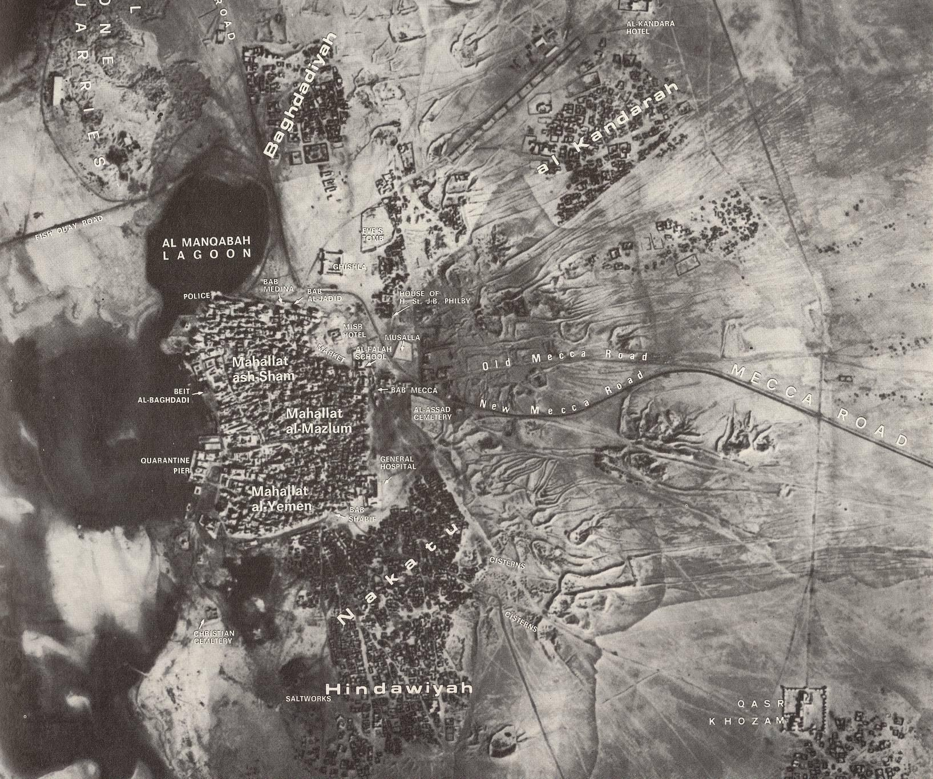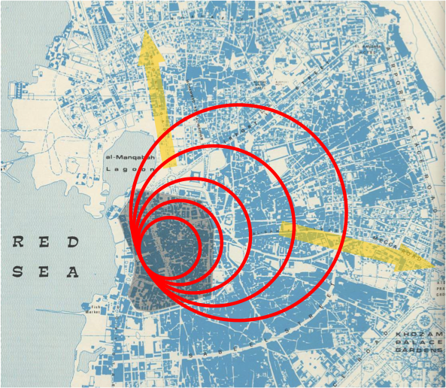
Figure 1: XXX

Datasets and methods
Here is an examploe of another chapter.

Results
Here are some important information for the short paper
- For illustration, the maximum number is 3 images. Make sure that the resolution is good (minimum 300dpi), but that they are not too heavy.
- You can also add some tables. Make sure that the tables are readable.
- The maximum size of short paper submitted is 20MB
- The maximum numbers of words for a long paper is 1800 words (not including abstracts and references)
- Deadline for submitting short paper is 15. January 2022.

Conclusions
Here you write the conclusions of your paper. For the references, we use the Harvard style. Below you see a couple of examples of the references.

REFERENCES

Please use the harvard style (Please delete before submission)
Hillier, B. (1999) ‘The Need for Domain Theories’, Environment and Planning B: Planning and Design, 26(2), pp. 163–167. doi: 10.1068/b2602ed.
Hillier, B. (2012) ‘Studying Cities to Learn about Minds: Some Possible Implications of Space Syntax for Spatial Cognition’, Environment and Planning B: Planning and Design, 39(1), pp. 12–32. doi: 10.1068/b34047t.

Additional Notes
- SHORT papers should be a maximum of 1800 words (not including references and abstract) and no more than 3 figures.
- Please use the insert figure caption option.
- figures and images should be high resolution (minimum 300dpi).
- The maximum size for SHORT papers submitted is 20Mb.

